WORLD TRADE CENTER SÃO PAULO BUSINESS CLUB
INTERNATIONAL BUSINESS DEPARTMENT

^{INVITES YOU TO:}
ABIMAPI’s 15th INTERNATIONAL CONGRESS
&
INTERNATIONAL BUSINESS ROUND

September 22nd – 24th 2016

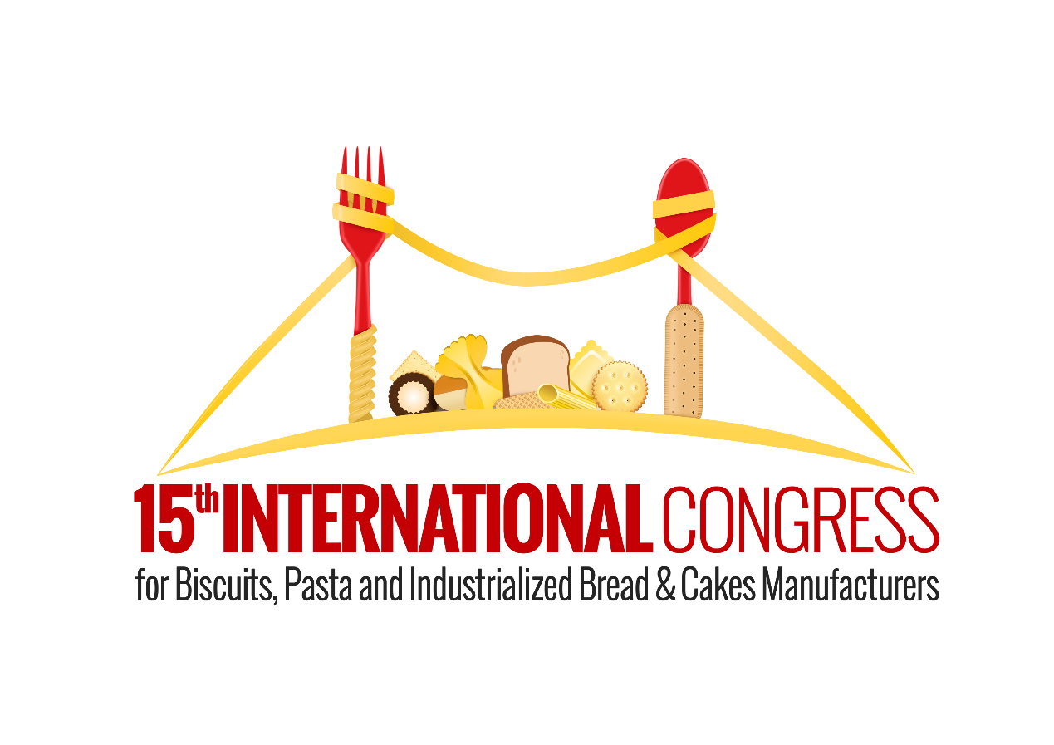

Dear ABIMAPI’s participators,

The World Trade Center Sao Paulo Business Club and ABIMAPI have the honor to invite you to ABIMAPÌ’s (Brazilian biscuits, cookies, pastas, cakes, and bread Association) Business Round and International Congress. The event will happen from September 22nd to 24th, in Florianopolis, Santa Catarina, Brazil.
The objective is to promote trade between Brazil and foreign countries in this segment to straighten bilateral relationships. This event will unite possible executives from twelve different countries, them being: Brazil, Bolivia, Chile, China, Colombia, Dominican Republic, Panama, Paraguay, Peru, Russia, South Africa, United Arab Emirates, United States of America. The ideal type of companies to come to Brazil are importers, distributors, traders and brokers that have interest in buying and doing business with Brazilian Companies that are listed in the presentation.
We will be responsible for your transport (plane tickets, airport reception, and departure), and hotel stay. For this to be possible, it is mandatory for you to fill out the participation form bellow. With these informations, ABIMAPI will analyze your profile to assure that it fits with their requisitions.
It’s important for the World Trade Center Sao Paulo Business Club to have the form filled out as soon as possible. This way, we can assure that your company will be analyzed precisely and have the best arrangements.
For further informations, and/or doubts, please don’t hesitate to contact.

WORLD TRADE CENTER SÃO PAULO BUSINESS CLUB
INTERNATIONAL BUSINESS DEPARTMENT

Participation Form

Company:_________________________Telephone:____________________________

Representative:_____________________Email:_______________________________

Country:_____________________State:_____________City:_____________________

Job Occupation:__________________________________________________________

Business Segment:_______________________________________________________

Website:_______________________________________________________________

About the company, core business and size:
Importer ( ); Distributor ( ); Retailer ( ); Wholesaler ( ); Investor ( );
Other ( ) __________

Size (Turnover + Imports):

Turnover: USD________; Volume/Value of imports: _______________

Main Import/Retail products:
Biscuit ( ) Pasta ( ) Cakes ( ) Bread ( ) Others ( )______________

Imported categories:
Dry ( ) Frozen ( ) Controlled Temperature ( )

Main interests in participating in ABIMAPI´s International Congress:
Expanding supplier options ( ) Developing New Business ( )

Please write about your intentions:

Which Brazilian companies would you like to meet?
Biscuit ( ) Pasta ( ) Cakes ( ) Bread ( ) Sweetener ( )

Please indicate company’s names from the attached document:

If it applies, please indicate your sales channels:

HORECA ( )
Supermarkets ( )
E-commerce ( )
Retailers ( )
Wholesalers ( )
Others ( ) ____________

Have you ever done business with Brazil? Yes ( ) No ( )

If so, please specify:

Complete Name: __________________

Signature:_______________________

